Overview
A for each loop is a special type of loop specifically designed for traversing arrays.

Consider this basic for loop:
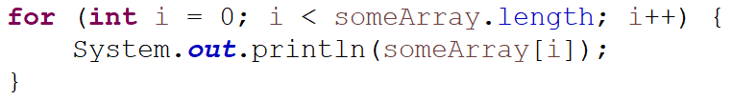
It prints all of the items in the array.

Here is a for each loop with identical behavior.
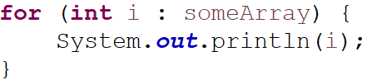
This loop also prints all of the items in the array. It can be read as:
For each integer (i) in someArray.

The variable declared in the loop (in this case an integer called i) will store each element of the array starting at index 0 and counting up to index length-1.
So on the first iteration of the loop: i = someArray[0]
on the second i = someArray[1],
then i = someArray[2] etc

Limitations of For Each
For each loops are primarily used for convenience and to make code faster to read and write.
A regular for loop can solve all of the same problems a for each loop does.
However, there are some problems a regular for loop solves that a for each does not.

For each loops do not let you modify the array
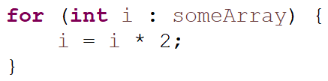

This modifies the temporary iterator variable, not the value stored in the array.

For each does not keep track of the index
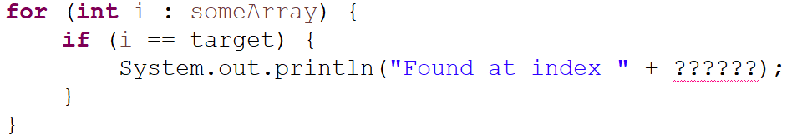

Say you wanted to find the index of a specific integer. You couldn't do that with a for each loop.

For each only iterates forward in single steps
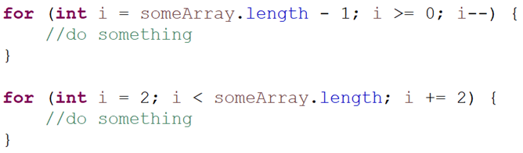
These two loops cannot be easily converted into for each loops.

